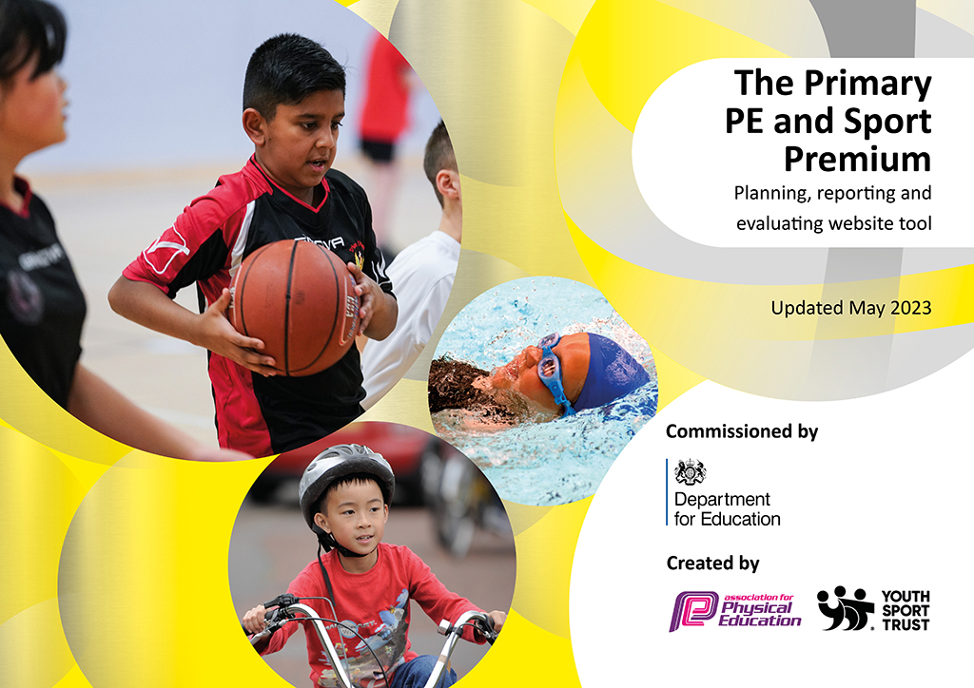
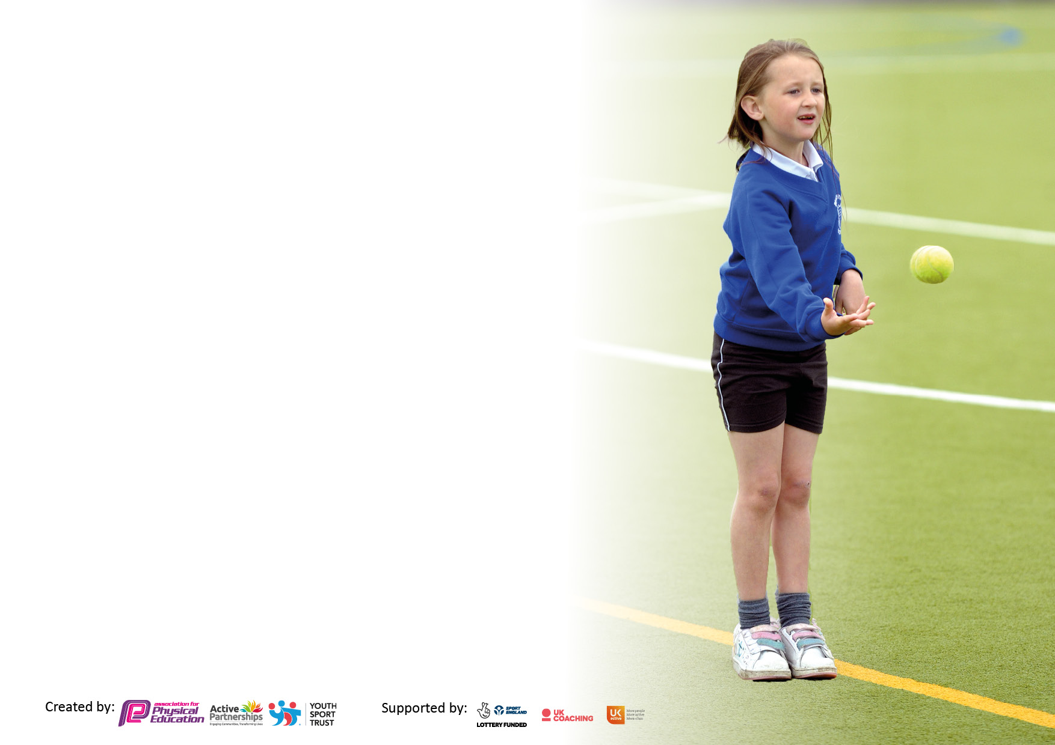

It is important that your grant is used effectively and based on school need. The Education Inspection Framework makes clear there will be a focus on ‘whether leaders and those responsible for governors all understand their respective roles and perform these in a way that enhances the effectiveness of the school’.

Under the Quality of Education Ofsted inspectors consider:
Intent - Curriculum design, coverage and appropriateness
Implementation - Curriculum delivery, Teaching (pedagogy) and Assessment
Impact - Attainment and progress

To assist schools with common transferable language this template has been developed to utilise the same three headings which should make your plans easily transferable between working documents.

Schools must use the funding to make additional and sustainable improvements to the quality of Physical Education, School Sport and Physical Activity (PESSPA) they offer. This means that you should use the Primary PE and sport premium to:

- Develop or add to the PESSPA activities that your school already offer
- Build capacity and capability within the school to ensure that improvements made now will benefit pupils joining the school in future years
- The Primary PE and sport premium should not be used to fund capital spend projects; the school’s budget should fund these.

Pleasevisitgov.ukfortherevisedDfEguidanceincludingthe5keyindicatorsacrosswhichschoolsshoulddemonstrate animprovement.Thisdocumentwillhelpyoutoreviewyourprovisionandtoreportyourspend.DfEencouragesschools to use this template as an effective way of meeting the reporting requirements of the Primary PE and Sport Premium.

We recommend you start by reflecting on the impact of current provision and reviewing the previous spend.

Schools are required to publish details of how they spend this funding, including any under-spend from 2021/2022, as well as on the impact it has on pupils’ PE and sport participation and attainment. All funding must be spent by 31st July 2023.

We recommend regularly updating the table and publishing it on your website throughout the year. This evidences your ongoing self-evaluation of how you are using the funding to secure maximum, sustainable impact. Final copy must be posted on your website by the end of the academic year and no later than the 31st July 2023. To see an example of how to complete the table please click HERE.

Details with regard to funding
Please complete the table below.

Total amount carried over from 2021/22 | £10,227
Total amount allocated for 2021/22 | £19,479
How much (if any) do you intend to carry over from this total fund into 2022/23? | £557
Total amount allocated for 2022/23 | £19,430
Total amount of funding for 2023/23. To be spent and reported on by 31st July 2023. | £19.987
Swimming Data
Please report on your Swimming Data below.

Meeting national curriculum requirements for swimming and water safety.

N.B. Complete this section to your best ability. For example you might have practised safe self-rescue techniques on dry land which you can then transfer to the pool when school swimming restarts.
Due to exceptional circumstances priority should be given to ensuring that pupils can perform safe self rescue even if they do not fully meet the first two requirements of the NC programme of study
What percentage of your current Year 6 cohort swim competently, confidently and proficiently over a distance of at least 25 metres?  N.B. Even though your pupils may swim in another year please report on their attainment on leaving primary school at the end of the summer term 2022.  Please see note above | 82%
What percentage of your current Year 6 cohort use a range of strokes effectively [for example, front crawl, backstroke and breaststroke]?  Please see note above | 67%
What percentage of your current Year 6 cohort perform safe self-rescue in different water-based situations? | 89%
Schools can choose to use the Primary PE and sport premium to provide additional provision for swimming but this must be for activity over and above the national curriculum requirements. Have you used it in this way? | Yes/No

Action Plan and Budget Tracking
Capture your intended annual spend against the 5 key indicators. Clarify the success criteria and evidence of impact that you intend to measure to evaluate for pupils today and for the future.

Academic Year: 2022/23 | Total fund allocated: | Date Updated:
Key indicator 1: The engagement of all pupils in regular physical activity – Chief Medical Officers guidelines recommend that primary school pupils undertake at least 30 minutes of physical activity a day in school |  |  |  | Percentage of total allocation:
 |  |  |  | 55%
Intent | Implementation |  | Impact
Your school focus should be clear what you want the pupils to know and be able to do and about  what they need to learn and to  consolidate through practice: | Make sure your actions to achieve are linked to your intentions: | Funding allocated: | Evidence of impact: what do pupils now know and what can they now do? What has changed?: | Sustainability and suggested next steps:
Swimming  - Provide booster swimming sessions to children in year 5 and 6 who cannot swim 25m. Offer the children the opportunity to take part in life saving sessions. | 1(i) Identify the children in year 5 and 6 who CANNOT swim 25m.  (ii) Provide 10 sessions of swimming for the children to ensure they meet the government standards before they leave primary school. |  | This didn’t happen due to school pool not operating.
Active Lunchtimes  Equipment and Resources for active lunchtime  - Have playground leaders (potentially house captains) to take an active role in organising and running break and lunchtime games for KS1 and KS2. Training to take place to ensure the children are prepared. | 2.Purchase equipment for children to use at lunchtimes to encourage more structured and active play.  Set up play leaders scheme.  Develop outdoor space to promote daily activity. | £1013  £9950 | Children are more active at lunchtime, they have more access to equipment to increase activity.  We have introduced play ground leaders using some children in year 5. This is helping the children to think of new games and have an active lunchtime. | Set up more formalised play leaders in Year 5.  Consider engaging in Skip 2b Fit.
Key indicator 2: The profile of PESSPA being raised across the school as a tool for whole school improvement |  |  |  | Percentage of total allocation:
 |  |  |  | 0%
Intent | Implementation |  | Impact
Your school focus should be clear what you want the pupils to know and be able to do and about  what they need to learn and to  consolidate through practice: | Make sure your actions to achieve are linked to your intentions: | Funding allocated: | Evidence of impact: what do pupils now know and what can they now do? What has changed?: | Sustainability and suggested next steps:
Links to secondary school  - Play Leaders. See above.  Continue and re-establish a link with a local secondary school | 1i) Continue to arrange meetings with Brakenhale head of PE, Mr Potter | £0 | This did not happen this year. | Re connect with Brakenhale in September.
House Captains  - Elect House captains (with the help of year 6 teachers) to also take on the role of sports captains. They will have a lead role in sport events, participation in lunchtimes games, participation in after school clubs. | 1i) Enable ALL Year 6 children the opportunity to represent Wildridings as Sports Captains. Job specification to be sent out to ensure children have enough time to deliver a speech to certain members/ children of the school.  ii) Children to visit KS1 and KS2 classses and ask which after school club (sport or non sport specific) the children would like members of staff to deliver.  iii) House/ sport Captains to also gauge an idea as to which lunchtime games children would like to have. These games are to also generate participation rates, less activity outside for the lunchtime staff and help promote inter house competitions. |  | The house captains applied for the role and were successful in their roles.  They were leaders at KS 1 Sports Day. | Send out pupil voice surveys.

Key indicator 3: Increased confidence, knowledge and skills of all staff in teaching PE and sport |  |  |  | Percentage of total allocation:
 |  |  |  | 12%
Intent | Implementation |  | Impact
Your school focus should be clear | Make sure your actions to | Funding | Evidence of impact: what do | Sustainability and suggested
what you want the pupils to know | achieve are linked to your | allocated: | pupils now know and what | next steps:
and be able to do and about | intentions: |  | can they now do? What has
what they need to learn and to |  |  | changed?:
consolidate through practice:
Staff CPD  Develop staff confidence in gymnastics. | Planned CPD using Get Set resources, Book in staff meeting. Purchase Get Set 4 PE scheme. | £450  £1000 | Good attendance from staff. High engagement and participation. Feedback afterwards. Learning walks indicated staff were teaching it in PE time. | Dance CPD.  Play Leader Training CPD.
Subject Leader Support  Strategically support the subject leader with visioning, long term planning, to embed PE, School sport, Physical Activity, Health and Wellbeing at the heart of the school. | Meet with Sport Impact on three training days.  Carry out a PE Review.  Action planning and impact reporting  Curriculum support  Sports Leaders support  Remote support via email | £963 | Improved confidence of the subject leader.  Detailed and effective action planning and reviewing process embedded. Clear vision for PE moving forward. Formalised Sports Leaders programme in the school. Development of pupil and staff voice within PE. Improved staff confidence through CPD.
Key indicator 4: Broader experience of a range of sports and activities offered to all pupils |  |  |  | Percentage of total allocation:
 |  |  |  | 1%
Intent | Implementation |  | Impact
Your school focus should be clear | Make sure your actions to | Funding | Evidence of impact: what do | Sustainability and suggested
what you want the pupils to know | achieve are linked to your | allocated: | pupils now know and what | next steps:
and be able to do and about | intentions: |  | can they now do? What has
what they need to learn and to |  |  | changed?:
consolidate through practice:
Extra-Curricular Clubs  - Introduce new after school clubs. | Ask teachers who would want to help run an after school club. This could be a sporting activity or not. I,e film club, book club, jewellery club, etc. | £0 | The children accessed the following clubs:  Netball Y5/6  Badminton Y5/6  Running club KS2  Cricket Y5/6  Street Dance KS1/2  Judo- all  Karate- all  Athletics KS2 | - Look at a minimal charge per club.  - Speak to Prestige about running clubs.
PE Curriculum  Ensure a broad and balanced PE curriculum. | Use Get Set to plan curriculum coverage and speak to staff.  Ensure that you cover the national curriculum requirements. | See above Get Set costs. | Children got a broad and balanced curriculum. | - Meet with site manager to organise the storage of PE equipment.  - Get feedback from year teams on PE curriculum. Use support on Get Set for curriculum planning,
Climbing  Introduce children to climbing. | Arrange for year 5/6 children to spend an afternoon at Oakwood climbing centre. | £220 (transport) | Children participated in climbing activities. | - Look into more opportunities.

Key indicator 5: Increased participation in competitive sport |  |  |  | Percentage of total allocation:
 |  |  |  | 18%
Intent | Implementation |  | Impact
Your school focus should be clear | Make sure your actions to | Funding | Evidence of impact: what do | Sustainability and suggested
what you want the pupils to know | achieve are linked to your | allocated: | pupils now know and what | next steps:
and be able to do and about | intentions: |  | can they now do? What has
what they need to learn and to |  |  | changed?:
consolidate through practice:
SLA  Buy into the BFC SLA for sports – | 3i) Complete documentation for the BFC SLA and ensure it reaches Matt Gamble  (ii) Ensure registration for events is completed on time and that training and coaching is accessed throughout the year. | £1869  £1,440  (cover) | Children get to represent their school and participate in competition. More children get to access competition at different levels. Links are made with local community provision. | Continue for next year.  Consider funding travel and supply cover.
Sports Day  - Deliver an Inter House Sports Day in KS 1 and 2. | Use Get Set resources to organise stations. Plan a range of differentiated competitive track races. Ensure it has both competitive and collaborative elements. | £240  (cover) | A successful, sports day. Children enjoyed the opportunity to be both competitive and collaborative. Feedback was good. | Engage with Secondary school for helpers for next year.

Signed off by
Head Teacher: | P Chandler
Date: | 21.7.23
Subject Leader: | Elise Miller
Date: | 14.7.23
Governor:
Date:

